**Power BI Project on Health Expenditure around the World**

**Table of Contents**

* Introduction
* DAX Formula Used in Summarized Table
* DAX Formulas Used in Measures
* Final Report
* Insights

**Introduction**

This project is aimed at developing a Power BI Report for generating insights about health expenditure data around the world.

**DAX Formulas Used in Summarize Table**

* Health Expenditure Summary = SUMMARIZE('Health Expenditure',Country[CountryID],'Year'[YearID],"Countryname", MAX(Country[CountryName]),"Year",MAX('Year'[Year]),"TotalExpenditure",SUM('Health Expenditure'[ExpenditureAmount]),"TotalGDP",AVERAGE(GDP[GDPAmount]),"TotalPopulation",sum(Population[PopulationCount]))

**DAX Formulas Used in Measures**

* Highest Expenditure = CALCULATE(max('Health Expenditure'[ExpenditureAmount]),ALL(Country[CountryName]))
* Lowest Expenditure = CALCULATE(MIN('Health Expenditure'[ExpenditureAmount]),ALL(Country[CountryName]))
* Total expenditure = sum('Health Expenditure'[ExpenditureAmount])
* Total expenditure_2020 = CALCULATE(SUM('Health Expenditure'[ExpenditureAmount]),'Health Expenditure'[YearID]=3)
* Total Population = SUM(Population[PopulationCount])
* Percentage of Heath Expenditure = DIVIDE(SUM('Health Expenditure'[ExpenditureAmount]),SUM(GDP[GDPAmount]),0)
* Percentage change in health expenditure for 2018-2019 = DIVIDE(CALCULATE(SUM('Health Expenditure'[ExpenditureAmount]),'Year'[Year]=2019)-CALCULATE(SUM('Health Expenditure'[ExpenditureAmount]),'Year'[Year]=2018),CALCULATE(SUM('Health Expenditure'[ExpenditureAmount]),'Year'[Year]=2018))
* Percentage change in health expenditure for 2019-2020 = DIVIDE(CALCULATE(SUM('Health Expenditure'[ExpenditureAmount]),'Year'[Year]=2020)-CALCULATE(SUM('Health Expenditure'[ExpenditureAmount]),'Year'[Year]=2019),CALCULATE(SUM('Health Expenditure'[ExpenditureAmount]),'Year'[Year]=2019)

**Final Report**

Health Expenditure by Countries:

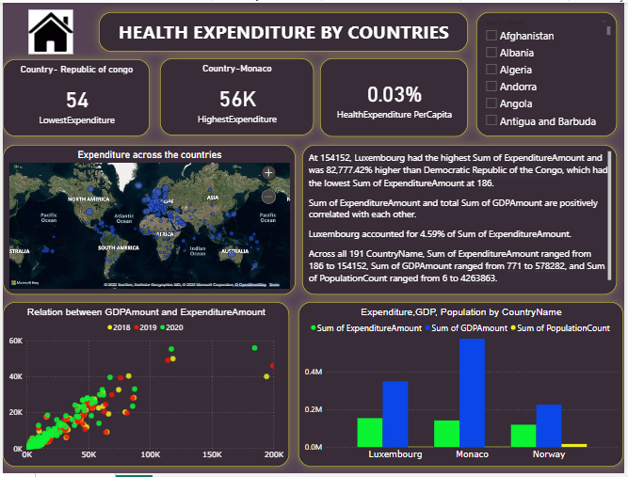

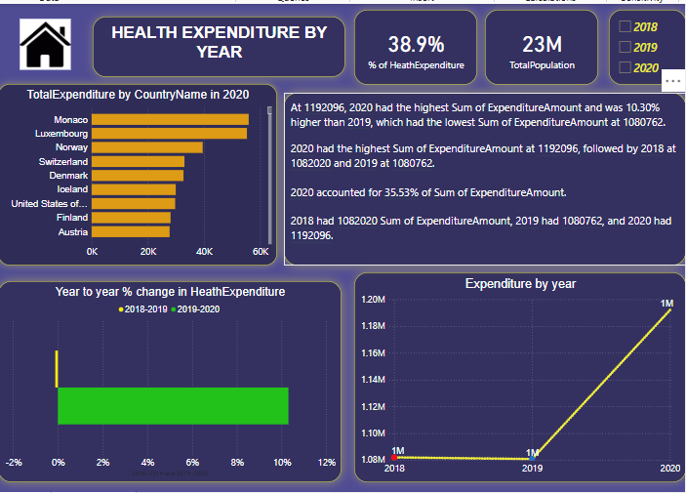Health Expenditure by year :

**Insights**

1. Luxembourg (Developed country) with GDP $349915 had the highest health expenditure $154152 and was 82777% higher than the Democratic Republic of Congo (poor country) with GDP $1627 had health expenditure $186.
2. Health Expenditure and GDP amount are positively correlated with each other.
3. Across all 191 countries Sum of health expenditure ranged from $186 to $154152, Sum of GDP ranged from $771 to $578282 from year 2018-2020.
4. 2020 had the highest health expenditure amount and was 10.30% higher than 2019 which had the lowest health expenditure.
5. 2020 had the highest health expenditure at $1192096 followed by 2018 at $1082020 and 2019 at $1080762.
6. Most populated countries like India and China, they had spent less money on health expenditure as compared to their population.
7. In all three years from 2018 to 2020 Monaco had the highest health expenditure in 2020 and Democratic Republic of Congo had the lowest health expenditure in 2020.